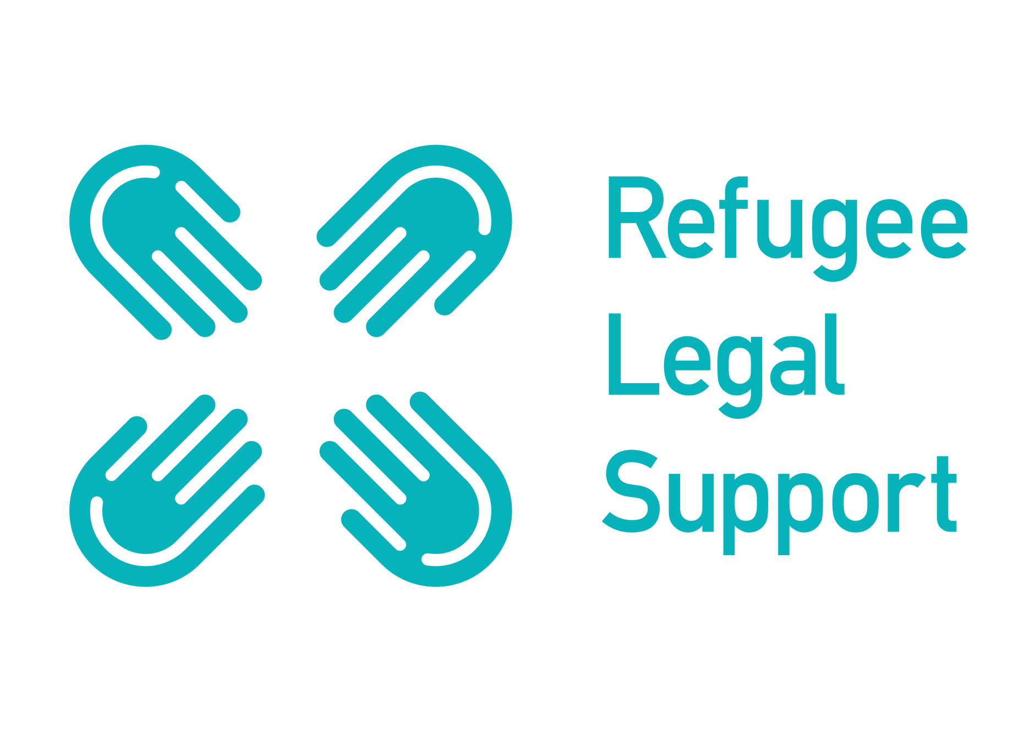

Family Reunion from Europe (FRFE) project

RLS is regulated in the UK by the OISC - Ref No. N202000126:
Refugee Legal Support is a registered charity (no 1191680) in England and a non-profit company in Greece

INITIAL CONTACT FORM
Form Ref No: RLS USE ONLY

Essential information

Refugee Legal Support (RLS) launched the Family Reunion From Europe (FRFE) project on February 1st 2021 with the support of five commercial law firms in the UK. This project aims at utilising pro bono capacity to help with family reunion work for applicants in Greece with family members in the UK following the Dublin Regulations coming to an end in December 2020.
This initial contact form is to be used by organisations or individuals wishing to refer a family reunion case for legal support to RLS. Please note that not all referrals will be accepted, but all of them will receive appropriate attention and feedback. A response to all referrals will be expected to be sent within seven working days of receipt in writing via email.
Please complete the form below according to the details on the person’s Greek International Protection Applicant’s Card and/or passport/national ID. If any information across documents is inconsistent please note this and provide any further details in the relevant fields. All fields marked with an asterisk (*) are mandatory. The ones without an asterisk are optional at this stage and you can leave them blank if you don’t know them or will take long to find them. All data included in this form and any email correspondence with RLS is covered by confidentiality and is governed by the applicable Data Protection laws in the UK. You can find RLS’s Data Protection Policy (DPP) and more on how the data in this form will be used by following this link. You can request a digital copy of RLS Data Protection policy by typing “YES” in the blank field below and by indicating an email address you would like us to send it to:
I want a copy of the RLS Data Protection Policy to be sent to me _______
I want the copy of the DPP to be sent to this email address: _________________________
Before filling out the form below, make sure you (if self-referring), the person you wish to refer or the sponsor in the UK do not have legal representation for the purposes of this particular family reunion case in the UK. We are unable to assist individuals who are already represented in this matter.
Completed referral forms as well as any queries regarding this form should be sent to FRFE Project Coordinator Efi Stathopoulou at coordinator.uk@refugeelegalsupport.org.
Date*: ……………….
Referred by*: ……………..
Please provide name, organisation and email/phone number of the person completing this form

Case number/reference with you, if any:

How did you hear about the project?*
RLS Social Media
RLS website
Refugee Legal Group in the UK
Other (please specify)

Has consent been obtained to make this referral? (Y/N)

Applicant = person in Greece you are referring
Sponsor = family member or relative in another European country that applicant wishes to reunite with
INFORMATION ON THE APPLICANT
First name of Applicant*
Surname of Applicant*
Nationality of Applicant*
Date of birth of Applicant*
Any inconsistencies between passport/national ID and asylum applicant’s card? If yes, please state specifically. You can also state aliases here
Phone number(s) *
specify if used for normal calls or/and WhatsApp
Email address*
Home Address or city/island where the Applicant resides*
Languages spoken*
Interpreter required?*
Specify the language and dialect as necessary
Any vulnerabilities?*
Any dependents?*
If yes, how many and how are they depending on the Applicant? If the Applicant has dependent children, please provide their ages
Is the Applicant in receipt of a GCA cash card as part of the UNHCR/ GCA cash assistance programme?
If yes, has the Applicant retained the UNHCR printed receipt provided upon registration for the cash card?
Is the Applicant in receipt of any other financial support, whether from the Sponsor in the UK or anyone else? If yes, how much per month?Does the Applicant have receipts / other evidence proving this?
Does the Applicant have any recent receipts evidencing their use of the cash card? If no, could they obtain one?
What is the Applicant’s total monthly income?
What expenses does the Applicant have? Can the Applicant provide receipts/ financial statements confirming this?
What is the immigration status of the Applicant in Greece? (i.e unregistered, registered asylum seeker, recognised refugee, subsidiary protection, humanitarian VISA etc)
Does the Applicant have a valid national passport?until when? If not, would it be safe and possible for them to obtain one?
If the Applicant has dependents, do the dependents have valid national passports? If not, would it be safe and possible for them to obtain one?

INFORMATION ON THE SPONSOR
First name of the Sponsor*
Surname of Sponsor*
Date of birth of the Sponsor*
Nationality of the Sponsor*
Phone number(s) *
specify if used for normal calls or/and WhatsApp
Email address*
Languages spoken*
Interpreter required?*
Specify the language and dialect as necessary
What is the relationship between the Applicant and the Sponsor?* Be as specific as possible
Immigration status of the Sponsor*
Does the Sponsor have a copy of their immigration record?

CASE HISTORY
Has the Applicant ever applied to join the Sponsor under the Dublin Regulations? If yes when was the EIU refusal letter issued or when was the Applicant notified?*
Has the Applicant ever applied to join the sponsor through any other legal route?* If yes, please specify

ADDITIONAL INFORMATION
(add any relevant comments or case summary-the box below is expandable)

